关于留学生缴费平台缴纳学费保险费操作流程
Steps to Pay Fees through JSU Online Payments System
(Admission Fees)

Step 1: Website: http://pay.ujs.edu.cn
Step 2: Username （用户名）is your student ID numbers （application number）and password （密码）is “oec?+passport number” , for example oec?G2374092
Step 3: Fill in verification code（验证码）
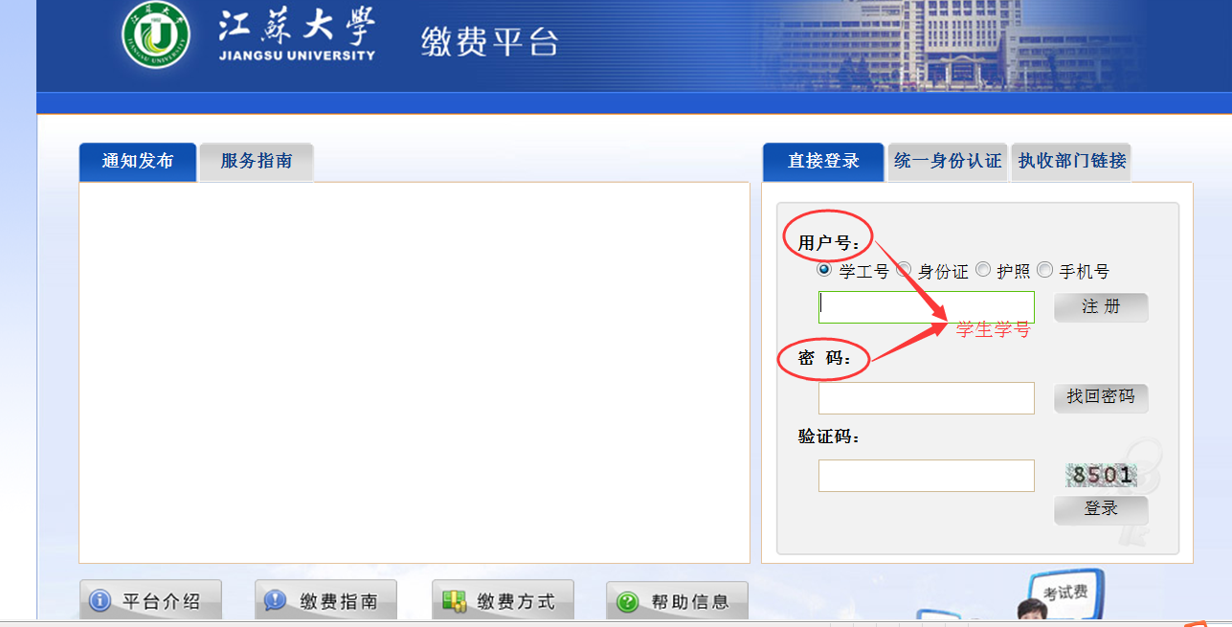
A pop-up asks for your mobile number and E-mail. After the information input, please log in again.
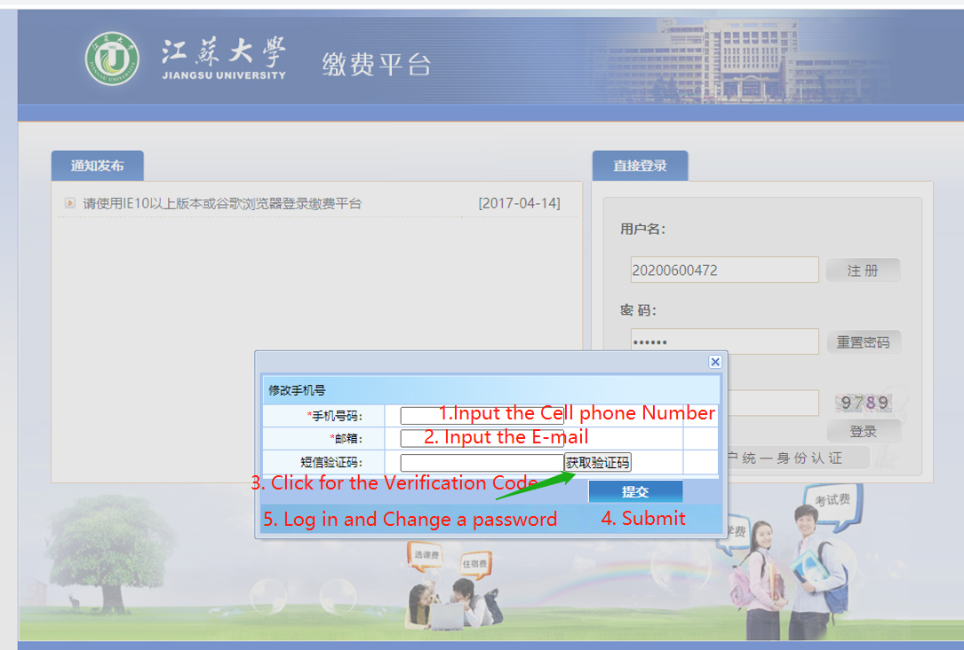
Step 4: Choose收费单位（receiver）as 财务处（Financial Department）
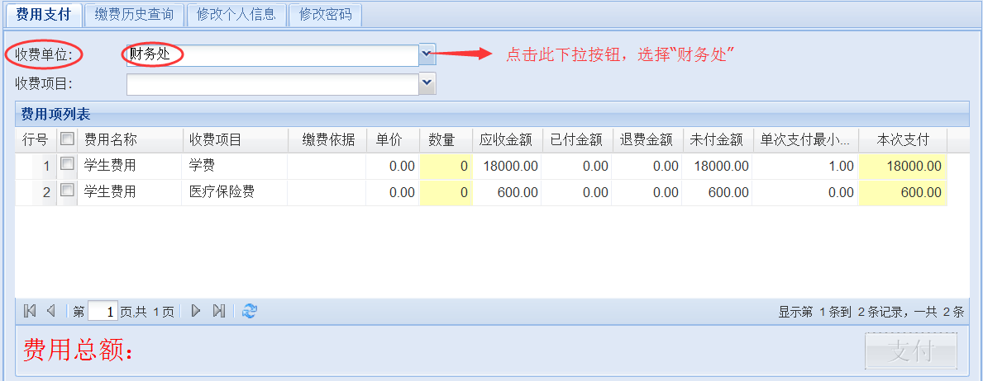
Step 5: The page shows your 申请费（Application Fees）and 座位费（Seat fees）. You can also find 应收金额（total）and also 未付金额（balance）of each item on this page.
NOTE: the application fees and seat fees can only be paid once.
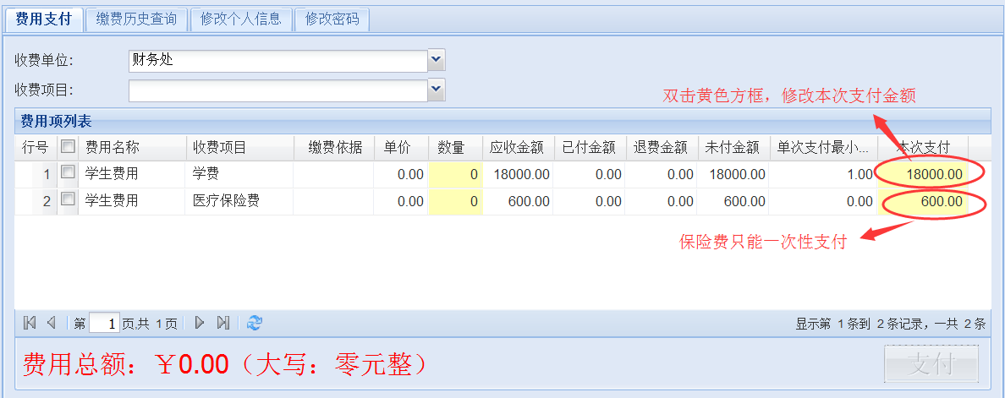

Step 6: Check the items you want to pay and the page shows 费用总额（Total amount you are about to pay）. Click 支付 at bottom right to pay.
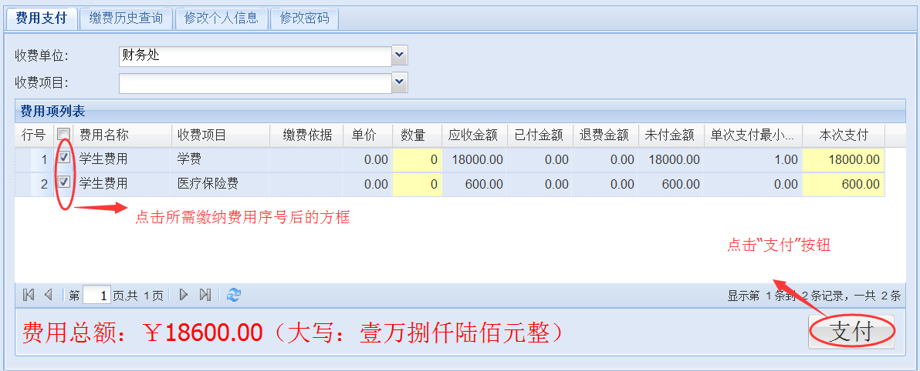

Step 7: Click 确定to confirm and proceed to transaction page.
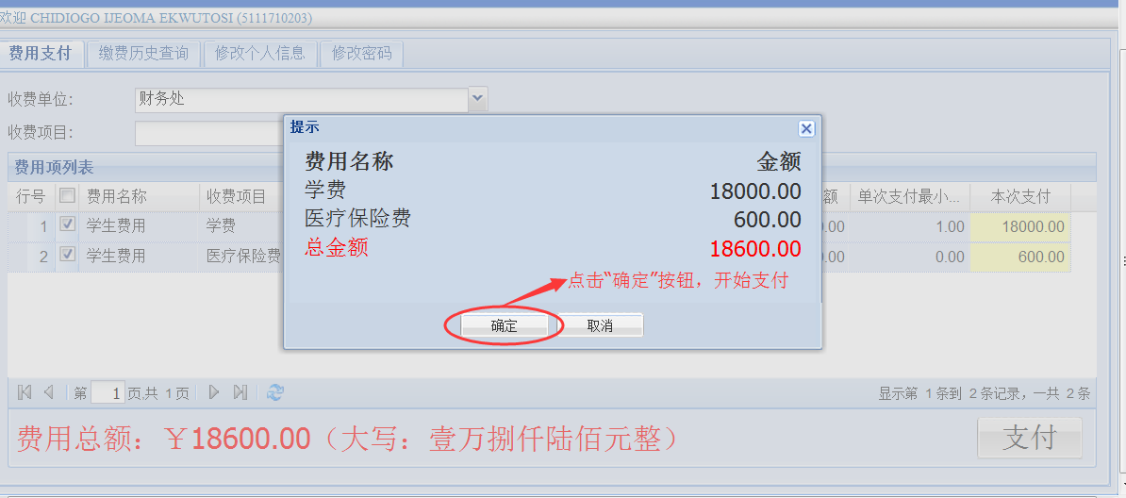

Step 8: Choose 支付类型 （Payment Type）as 网银付款（Internet Banking）. You can choose your bank or also the UnionPay which supports most Chinese bank cards. Click 下一步 to proceed for payment.
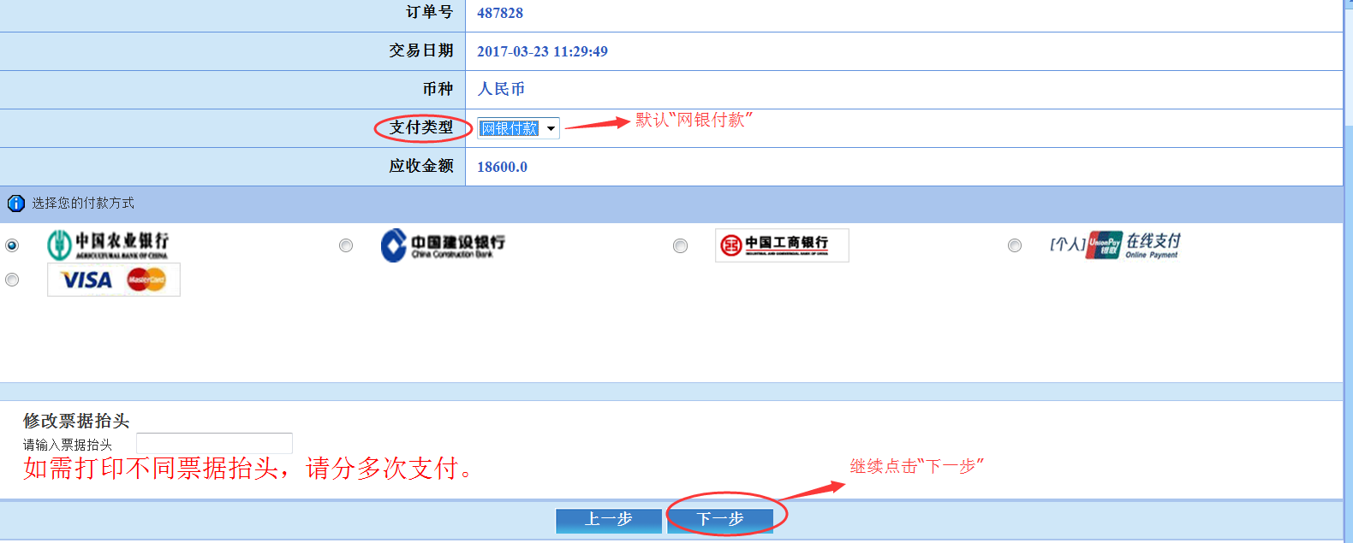

The ways that you can pay your fees:
Option1:choose the one of the three banks, and then click 下一步
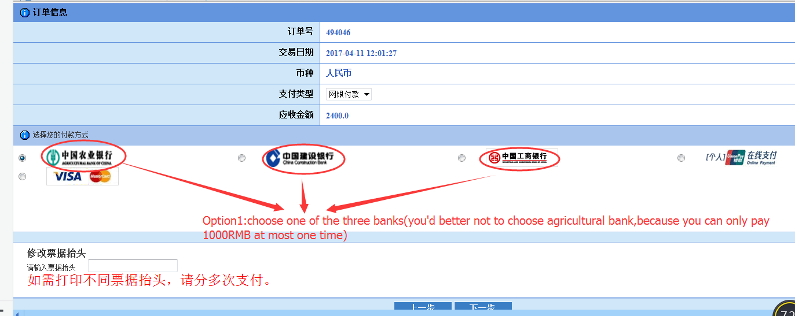
And fill in your phone number and the last six digits of your bank card, click 下一步 to finish paying your fees.
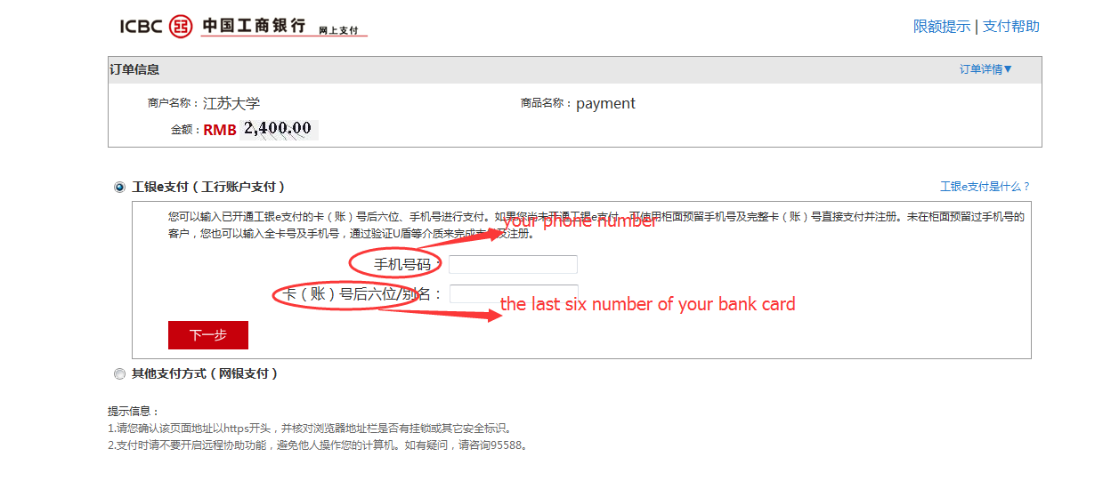
Option2:choose the unionpay, and then click 下一步
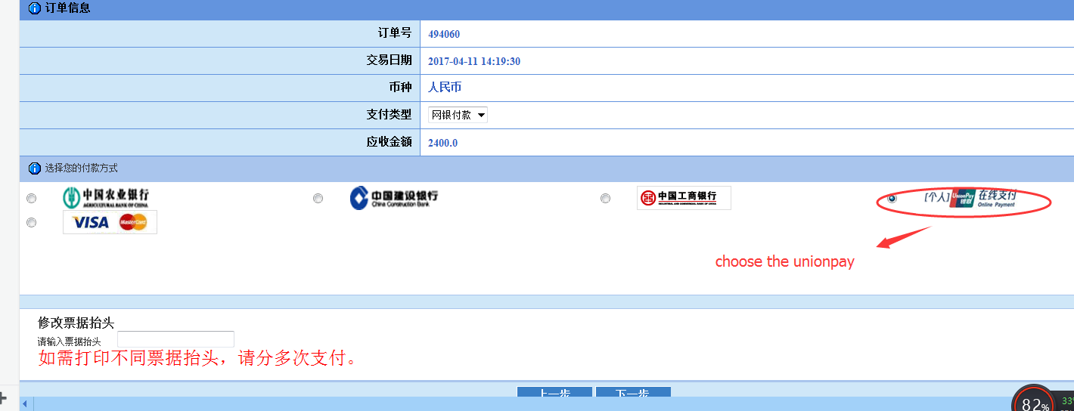
Choose one of the banks you want to pay, for example : bank of China, and click 到网上银行支付
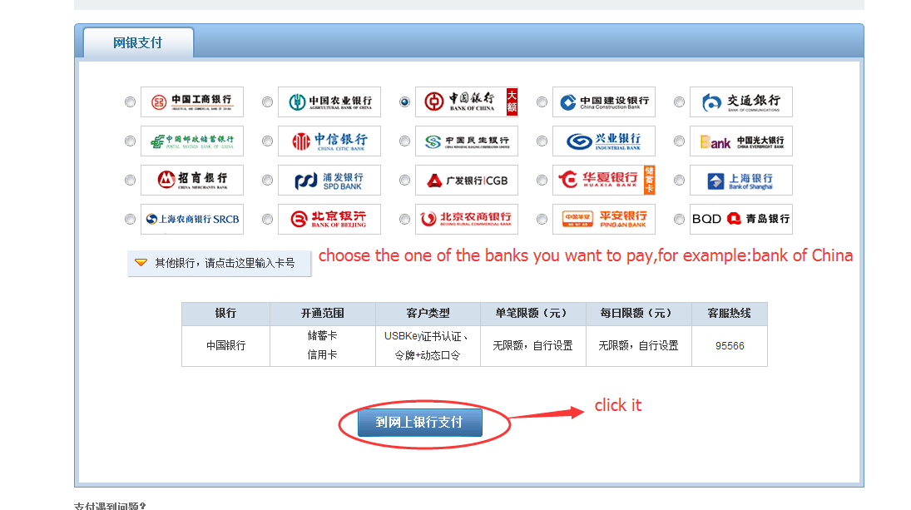
Fill in the name of your bank account, the password of your bank card, and then click 确定 to finish paying your fees.
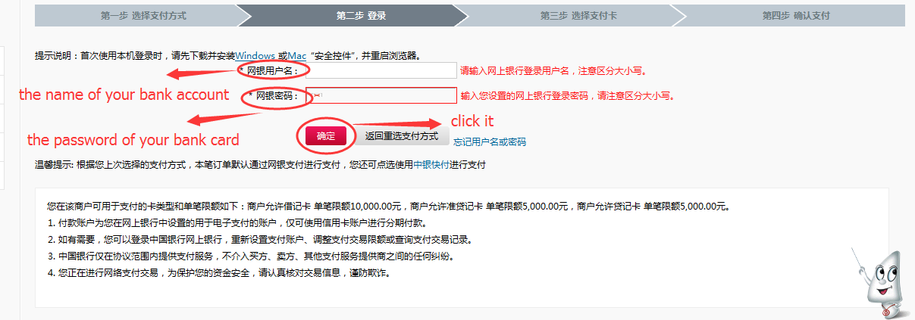
PS: the bank account name shall be 100% consistent with the one in bank system. You can refer to the bank slip given by the bank.

Option3:choose VISA and then click 下一步
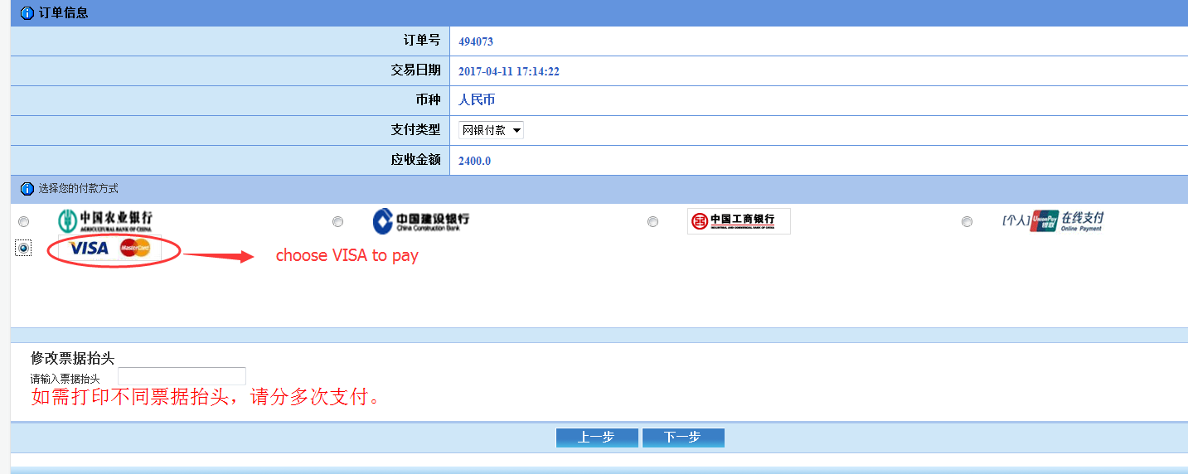
Fill in your first name, last name and card number, and click continue to finish paying your fees.
